Monterey Bay Aquarium: It can be Shark Week every week thanks to live online footage of Monterey Bay's Habitat exhibit.
Oxford University's History of Science Museum. Oxford, England
Museo Galileo.
Natural History Museum (NHM) in London.
San Diego Zoo |  | The San Diego Zoo has a website just for kids with amazing videos, activities, and games. Enjoy the tour!
Yellowstone National Park Virtual Field Trip | 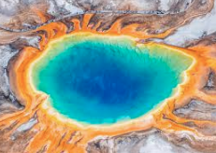 | Mud Volcano, Mammoth Hot Springs, and so much more.  Tour Yellowstone National Park!
MARS!!! | 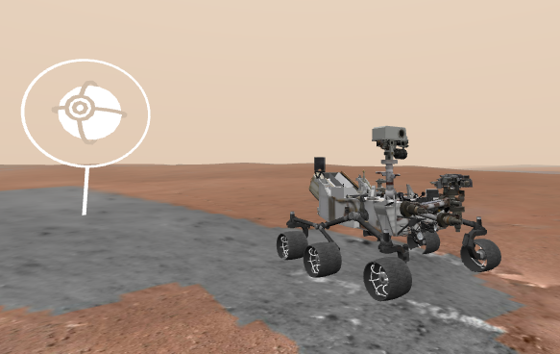 | Explore the surface of Mars on the Curiosity Rover.  They are updating from WEBVR to WEBXR now, but 360 Mode offers a digital view!
Animal Cameras | 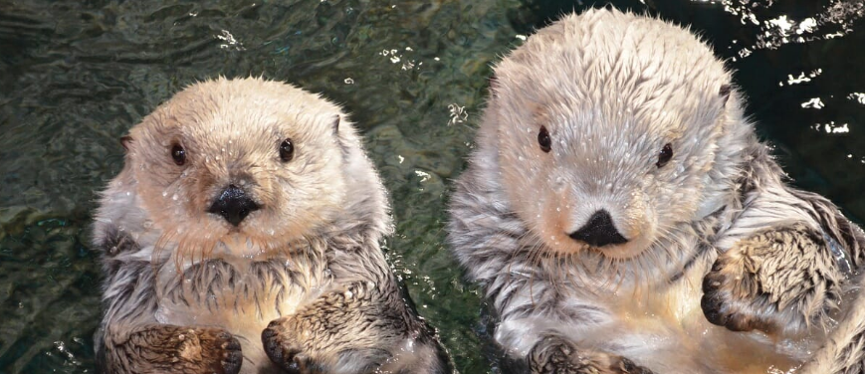 | Live Cams at the San Diego Zoo  Monterey Bay Aquarium live cams  Panda Cam at Zoo Atlanta  6 Animal Cams at Houston Zoo  Georgia Aquarium has Jellyfish, Beluga Whales, and more
Virtual Farm  Tour |  | This Canadian site FarmFood 360 offers  11 Virtual Tours of farms from minks, pigs, and cows, to apples and eggs.
U.S. Space and Rocket Museum in Huntsville, AL | 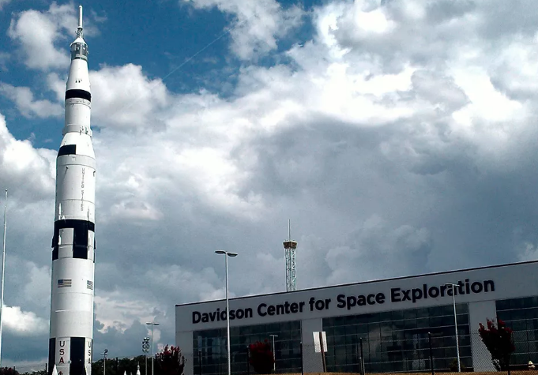 | See the Saturn 5 Rocket on YouTube and more on this tour thanks to a real father/son outing.
Discovery Education Virtual Field Trips |  | A few of the field trip topics include  Polar Bears and the Tundra  Social Emotional Skills  STEM  manufacturing
Dauphin Island Sea Lab Facebook Live |  | https://www.facebook.com/disealab/  Facebook Live. 10 am on weekdays

